CCT College Dublin

Assessment Cover Page

Module Title: | Strategic Thinking
Assessment Title: | CA3
Lecturer Name: | Taufique Ahmed
Student Full Name: | Renata Oliveira Souza
Student Number: | 2025064
Assessment Due Date: | 23 November 2025
Date of Submission: | 23 November 2025

By submitting this assessment, I confirm that I have read the CCT policy on Academic Misconduct and understand the implications of submitting work that is not my own or does not appropriately reference material taken from a third party or other source. I declare it to be my own work and that all material from third parties has been appropriately referenced. I further confirm that this work has not previously been submitted for assessment by myself or someone else in CCT College Dublin or any other higher education institution.

Table of Contents
- Introduction
- Business and Market Context
- IT Infrastructure and Competitive Advantage
- Technology Choices: Open Source vs Proprietary
- Strategic Business Analysis (PESTEL + SWOT)
• 5.1 PESTEL Analysis
• 5.2 SWOT Analysis
- Methodology
• 6.1 Dataset Description
• 6.2 Data Preparation
• 6.3 Exploratory Data Analysis (EDA)
• 6.4 Machine Learning Models
• 6.5 Hyperparameter Tuning
• 6.6 Model Validation Metrics
- Machine Learning Results and Validation
- Model Interpretability
- Emerging Technologies and Business Impact
- Ethics, Fairness and Transparency
- Project Challenges and Management
- Conclusion
- References

- Introduction
Since digitalization, social media, and consumer interest in health and fitness body-related products have shifted recent trends, the fashion and activewear industrie have transformed rapidly. Aesthetic and influencer promoted, anti-cellulite leggings are in especially high demand because of their compression and marketed benefits. Ultimately, the focus of strategic decision-making has shifted to available data, analytic and technology capabilities. Companies that are able to implement information systems, analytics, and market intelliogs to data streams have the most competitive advantages and integrate systems to capture their data streams and analytics systems to market their products.
This report corresponds to the Strategic Thinking module and builds on projects completed in semester one. While the focus of previous assessments has involved data and machine learning, this report encompasses a more holistic perspective to assess the project in a strategic, technological, and organizational way to analyze customer behavior, and how technology and data analytics can support the activewear industry’s sustainable competitiveness.
The project uses the Women's E-Commerce Clothing Reviews dataset available on Kaggle alongside synthetic pricing, customer country, and sales channel variables representing plausible online fashion retail data. The artefact encompasses EDA, various iterations and tuning of three different machine learning models, and model explainability to uncover the contribution of different variables, or predictors, on customer recommendations. Nevertheless, for the purposes of this module, the technical artefact demonstrates the more strategic aspect of the assessment.
As such, the report has four objectives:
To explore the nexus between IT infrastructure and the organisation's competitive advantage, and how data and analytics can position an activewear brand, especially one that sells anti-cellulite leggings.
To describe the technology choices made for the project and assess their strategic consequences while comparing the open-source (Python, Jupyter, scikit-learn) to the commercial options.
To apply the PESTEL and SWOT strategic analysis frameworks to discern the external context of the digital fashion marketplace.
To evaluate the customer data and predictive models used in the consumer-facing context from the ethical, social, and organisational perspectives.
The report shows how modern analytical capabilities can enhance an organisation's product strategy and customer targeting, enabling the optimisation of marketing and the construction of sustainable differentiation in competitive environments. The report broadens the scope of the project from pure estimation to the application of strategic thinking, demonstrating the extent to which IT-enabled capabilities facilitate organisational decision-making and performance.

- Business Context and Market Context
The business context for this project is a digitally led fashion retailing business selling anti-cellulite leggings. The leggings combine style with body support and a smoothing technology to help reduce the appearance of cellulite while working out. The product is a perfect fit for the current audience as it leverages the visibility of fitness, wellness and the athletic look promoted on Instagram, TikTok and YouTube. Target consumers have high social media engagement, respond to advocates, and peer reviews are crucial to their purchase decisions.
The overall value proposition of the brand hinges on:
Aesthetic - leggings to help the wearer look good and feel confident
Functionality - leggings designed for comfort, breathability and compression to enhance performance
Digital - leggings are sold via an e-commerce platform and can be purchased on social media.
Primarily consisting of women aged between 20 and 50, our target market regularly purchases activewear and possesses keen interests in health and self-care. Unlike luxury consumers, these customers tend to demonstrate greater price sensitivity, although they do place high value on reviews, social proof, and quality as well.
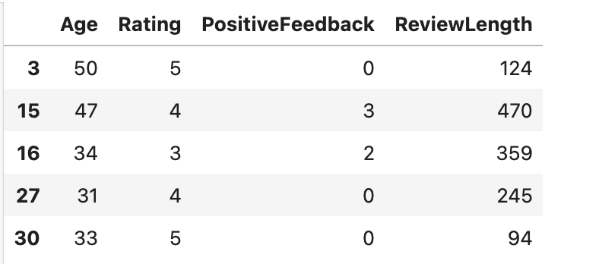

- The Role of IT Infrastructure and Strategic Advantage
Critically assess how the various components of IT infrastructures act as facilitators of the competitive advantage of a firm.
Information Technology (IT) infrastructures give modern businesses the abilities to gather, store, manipulate, and analyze data with unprecedented efficiency and scale. With respect to this particular project, IT infrastructures are much more than tools to assist the development of a machine learning model. They are strategic devices that allow the activewear firm to discern customer preferences, individualize the marketing effort, and achieve sustained competitive advantage in an adaptive and cutthroat marketplace.
The facilities that support the creation of the artefact comprise of components that are illustrative of the so-called analytical environments of the real world. Together, these components create an ecosystem that consolidates data sources, analytics, modeling, and collaboration:
1. The Data Source Layer
For this project, a dataset of consumer reviews obtained from Kaggle was utilized. While the dataset was not specifically designed for anti-cellulite leggings, it encapsulated typical ratings, reviews, and demographic data an e-commerce customer might provide. Synthesized variables such as price, country, and sales channel were incorporated to give the dataset a semblance of a real business context. This mirrors the data augmentation practices used in real-world organizations to enrich incomplete datasets and improve data analytics.
2. Processing and Analytics Layer
Using open-source technologies that include Python, Jupyter Notebook, NumPy, pandas, seaborn, and scikit-learn, an analytical environment has been developed which processes structured data and carries out exploratory analysis, feature engineering, and executes machine learning tasks.
This layer provides competitive edge because:
* Fast, cost-efficient iterative experimentation is possible.
* Processing of data can be automated and adjusted for other data sets.
* The organisation achieves analytical responsiveness and can act faster on changing business opportunities.
* Insights can be produced instantaneously for marketing decision.

3. Machine Learning and Model Development Layer
This project includes models of Logistic Regression, Random Forest, and Gradient Boosting. While these models are part of the artefact in technical terms, in reality, they represent a greater capability of the organisation: predictive analytics.
Predictive analytics afford competitive edge by:
* Determining customers who are most likely to recommend the product
* High-value and low-value customers can be segmented
* Marketing budgets can be optimized
* Based on predicted behaviour, content can be personalised
* Certain markets or age groups can be prioritized due to higher profitability.
This capability is a significant differentiator for an activewear brand in a highly competitive digital marketplace.

4. Layer of Version Control and Teamwork
Collaboration and version control takes place on GitHub. This helps with the strategic objectives of the project because:
-all contribution and updates can be traced;
-it allows transparent development, which is aligned with the ethical approach;
-it encourages teamwork, even among geographically dispersed teams;
-it helps the organisation to adopt good software engineering practices.

Organisational Impact and Competitive Advantage
The relationship between IT infrastructure and competitive advantage stems from the organisation’s ability to turn data into valuable assets. For an activewear brand selling anti-cellulite leggings, this transformation happens through:
- more effective customer acquisition;
- better product-market fit through understanding customer preferences;
- improved recommendation and remarketing;
- higher customer retention from personalisation;
- more efficient targeting that leads to costs savings.
Companies that do not have strong IT and analytics infrastructure are more likely to act on gut feel. In contrast, those that have analytics embedded into their IT infrastructure are more likely to respond to shifting market needs, proactively act to shape consumer behaviour and achieve market differentiation.
In summary, the informed application of the IT tools utilized in this project clearly illustrates that even thin layers of analytical infrastructure can deliver meaningful competitive advantage. Not from the tools per se, but from the manner in which they are woven into the organisation’s processes, decision making and planning.
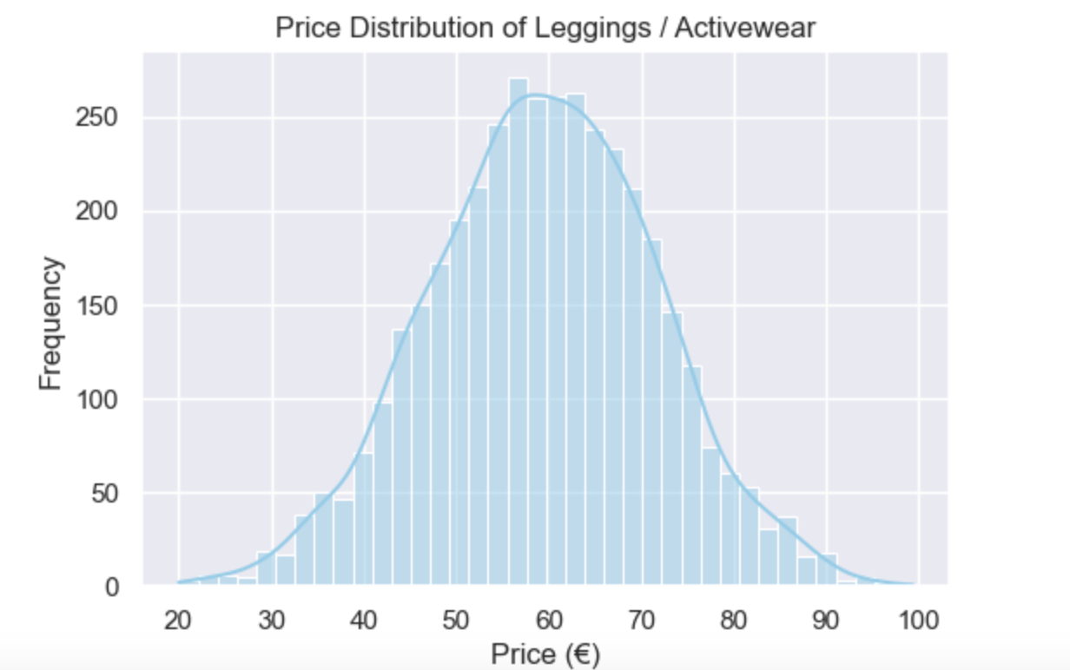

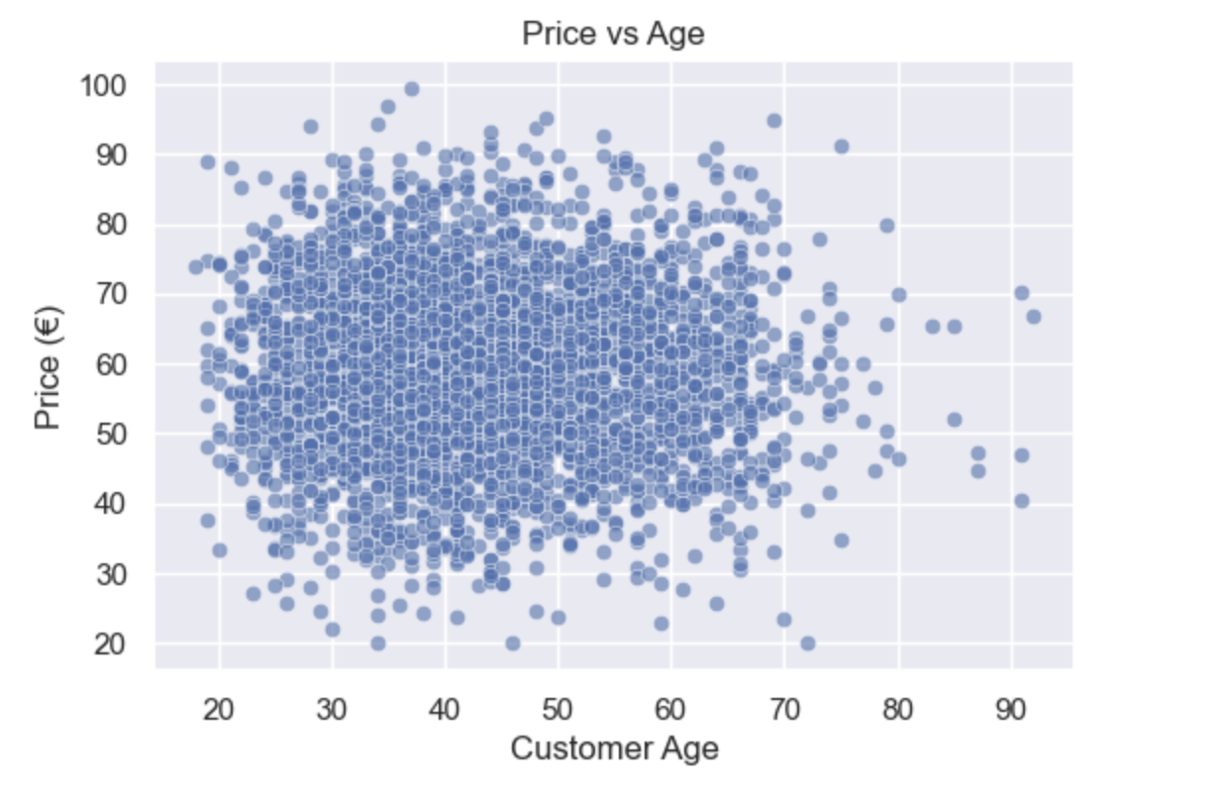

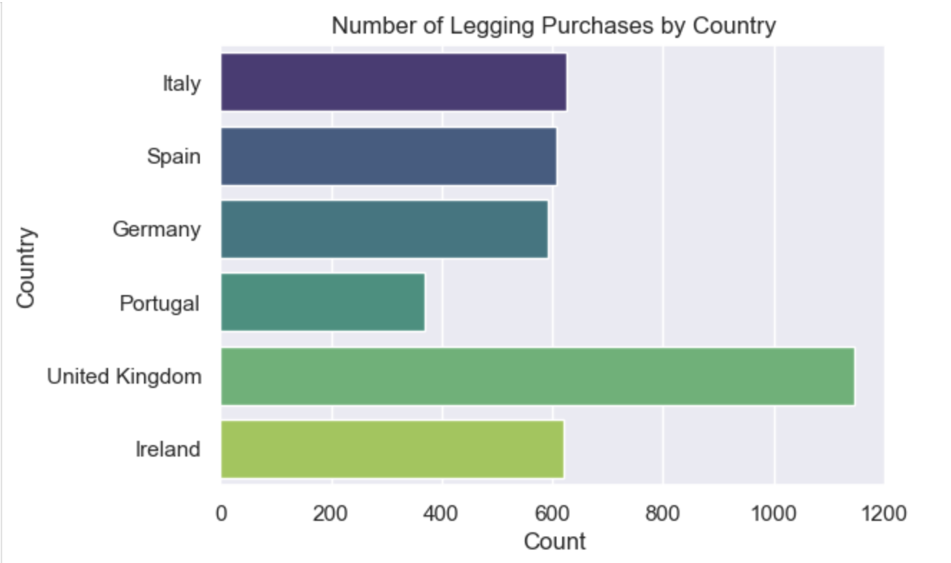

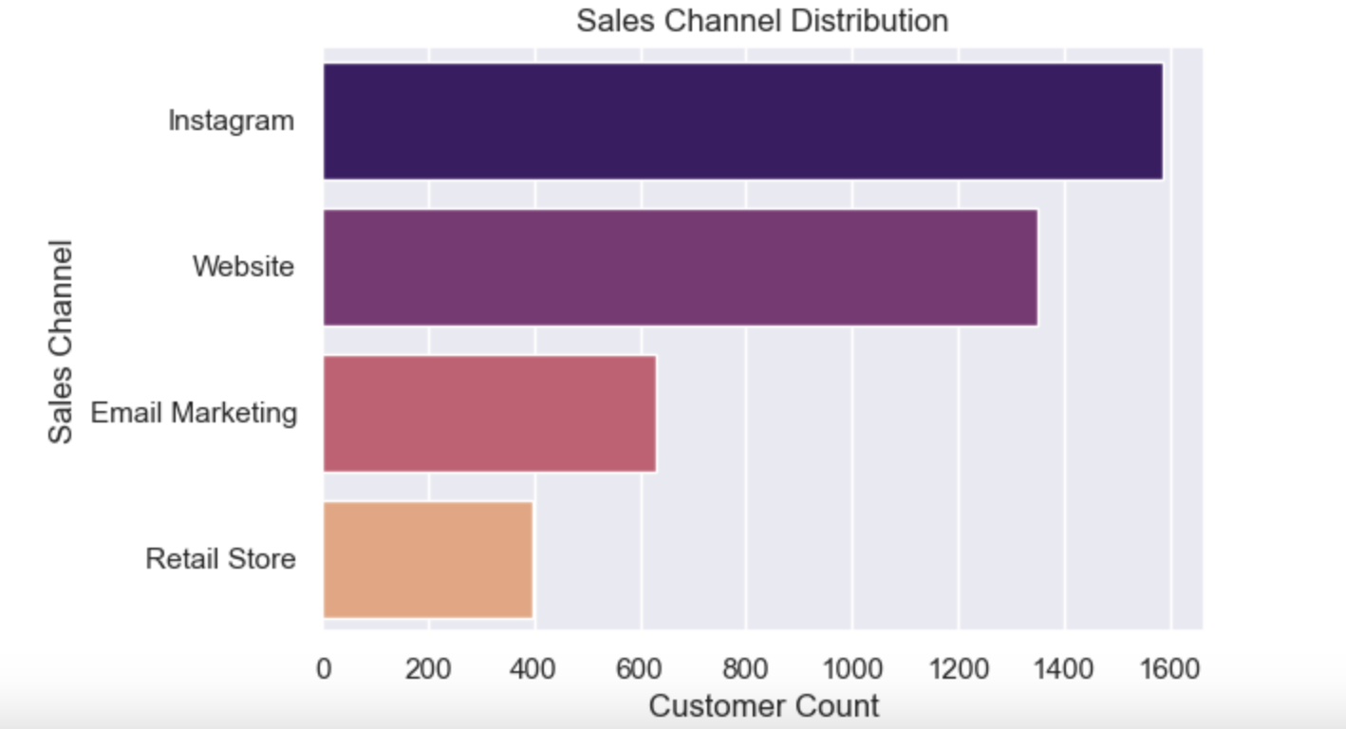

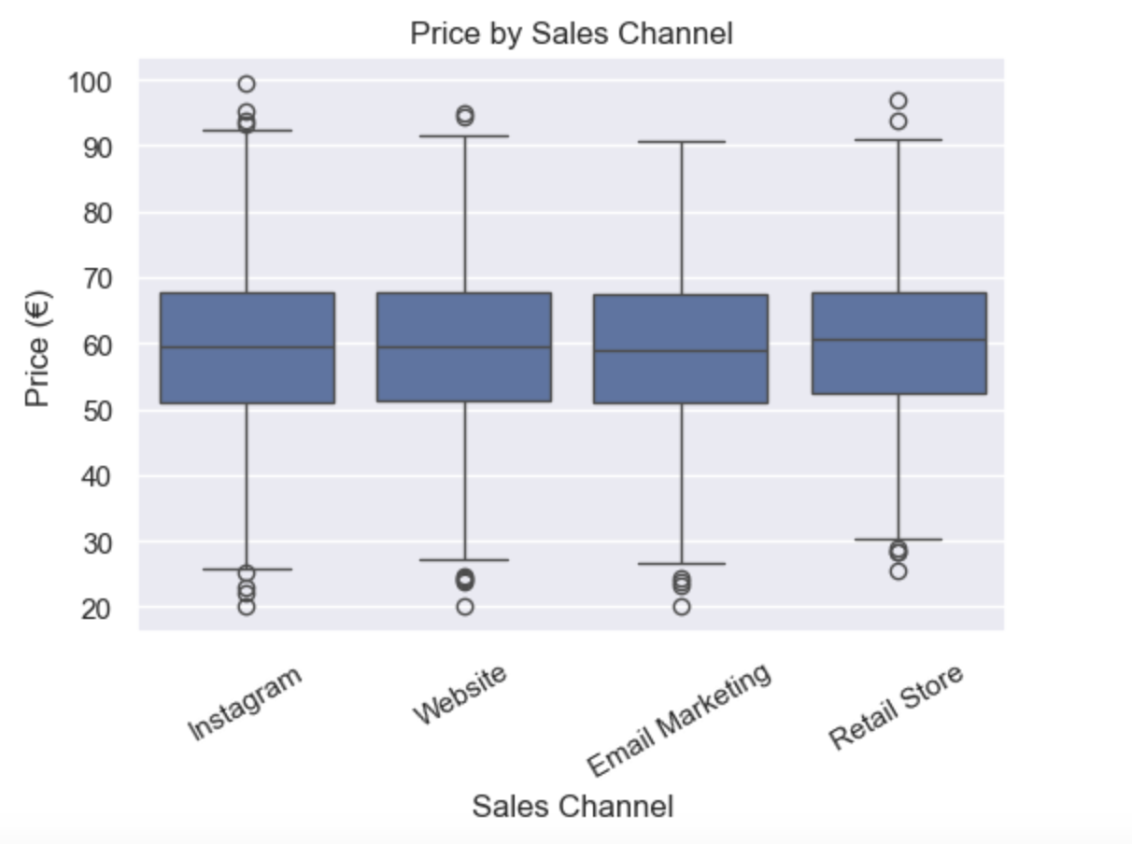

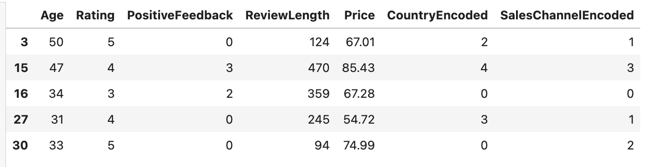

- OPEN-SOURCE TECHNOLOGY VERSUS PROPRIETARY TECHNOLOGY
Choosing which technology to implement is a long-term consideration with operational consequences, as it will affect a firm's productivity, costs, analytical capabilities, and overall ability to compete in the market. In this situation, balancing considerations, such as the cost, organizational consequences, flexibility, scalability, and ability to integrate with other systems, was made to determine which suite of open source and proprietary resources to use.

Open-Source Technologies Used in the Artefact
1.The project depends on open source software, such as python, which is the primary programming language; jupyter notebook, which is an open-source interactive development environment; NumPy, pandas, seaborn, and matplotlib, which are software packages for the manipulation and visualization of data; scikit-learn, which is an ML library for training and tuning models; git, which is an open-source software for version control; github, which is an open-source repository hosting service.
These technologies deliver a number of strategic considerations:
a. Cost Efficiency
The ability to use open-source technologies removes the licensing cost and drastically lowers operational costs, which is beneficial to new fashion brands and small retailers, as it will allow the firm to direct the capital that would have been used to purchase software into other areas such as marketing, product development, or logistics.
b. Flexibility and Customization
With open-source tools, there is always complete transparency in the code and the ability to customize it. In contrast to proprietary software, which may have rigid functionality or be locked behind a subscription paywall, open-source options do not have this constraint, as organizations are able to custom design tools to suit specific requirements.
c. Accelerated Change
Python’s ecosystem constantly changes as contributors from around the world come together. This provides companies with fast access to cutting-edge technology, including machine learning techniques, visualization methods, and new industry best practices.
d. Flexibility and Compatibility
Python and cloud-based open-source software work well with modern systems (AWS, Azure, GCP), providing the foundation for future growth.
2. Competitor Proprietary Solutions and Their Impact
Leading proprietary products in the domain are:
Visualization – Tableau, Power BI
Statistical modeling – SAS, SPSS
Enterprise ML Platforms – Azure Machine Learning Studio, Google Vertex AI, IBM Watson
Customer Behavior Analytics – Adobe Analytics
Proprietary products provide features such as dedicated support, unified dashboards, and dashboards, as well as preconfigured components. However, they come with the following strategic drawbacks:
a. Significant Expense and Licensing Limitations
Proprietary products are characterized by recurring subscription fees, or per-user licensing, which hinders adoption by smaller organizations.
b. Vendor Lock-In
An organization may become captive to a single vendor, which decreases the organization’s flexibility and increases costs.
c. Minimal Flexibility
Proprietary products give less modeling flexibility. For example, distributed systems such as Python, which provide advanced modeling with reduced access to the source code, are more difficult to access.
3. Strategic Assessment
For this project, the open-source ecosystem aligns strongly with the organisation’s strategic goals:
Assists in marketing testing (A/B, customer filtering).
Enables improvement of predictive models.
Delivers agility, a key in the ever-changing fashion industry.
Cuts down on expenses, allowing competition with bigger players.
Ensures openness and reproducibility, which are cornerstones of ethical AI.
While proprietary instruments may improve reporting and user-friendly dashboarding, they are not enough to outweigh the strategic advantages of flexibility of open-source software, especially for a digital-first activewear retailer.
4. Closing Remarks
Open-source technologies employed in the artefact offer strategic benefits, are economical, and fit the digital transformation aspirations of an organisation in the activewear industry. They allow more advanced and fast iteration of the development cycle, coupled with the ability to tailor the analysis pipeline to fit specific needs. Hence, open-source infrastructure is the best option for this undertaking.

- STRATEGIC BUSINESS ANALYSIS (PESTEL AND SWOT)
Identifying the company’s strengths and weaknesses by working with both the internal and external environments is fundamental for devising a company operating within the industrial and activewear sector with the requisite efficient and sustainable business strategy. The PESTEL and SWOT models assess the external and internal factors and how they impact the brand using models in business management.
5.1.PESTEL Analysis
Political Factors
Fashion retailers selling their products primarily online face international trade issues and regulations such as customs, cross-border taxes, and imports. Political unrest in countries where the production is being sourced from can derail or block the entire supply chain, altering the production costs and the times of deliveries.
Economic Factors
Consumer spending on the fitness apparel category is greatly influenced by the overall economy, disposable income, and rates of inflation. Recessions decrease purchasing power. In such situations consumers tend to buy cheaper alternatives. This fact means pricing of such products as anti-cellulite leggings will have to depend on the economic state of a given region.
Social Factors
The increasing social media trends and social media focus wellness activities have a positive impact and they also appreciate and encourage a positive body image. The demand is for increased activewear. The comfort, functionality and design of anti-cellulite leggings is demandable. The social review is also a great influencer.
Technological Factors
Advancements in tech continue assist in both production (smart fabrics, seamless knitting) and in sales (AI driven marketing, recommendation systems, digital ads). More precisely, artificial intelligence helps in accurately predicting consumer behavior and personalizing content which leads to increased retention and conversions.
Environmental Factors
The fashion industry suffers majorly in the environmental sustainability aspect. There is growing demand from an eco friendly customer base for sustainable, ethically and transparently sourced materials. Brands and companies often suffer from a damaged public image when environmental issues are ignored.
Legal Factors
There are a number of laws which companies have to consider and abide by, including data privacy laws (GDPR), consumer protection laws, and transparency laws. In an
organizational and legal sense, the ethical use of customer data is of paramount importance.
5.2. SWOT Analysis
Strengths
Product differentiation thanks to the anti-cellulite technology;
Strong affinity in the target market of fitness-informed women aged 20–50;
Scalable sales thanks to digital-first distribution;
Targeted marketing backed by machine learning and analytics.
Weaknesses
Social media exposure is infinitesimal;
Intense competition from larger companies in the sporting goods industry;
Potential class imbalance in customer sentiment data;
Limited number of physical retail stores.
Opportunities
The expansion of e-commerce and influencer marketing;
International market expansion, targeting countries with high usage of Instagram;
Targeted promotion through machine learning;
Creation of a line of products with a commitment to environmental sustainability.
Threats
Fast-fashion competitors offering lower prices;
Social media visibility altered by changes in algorithm;
Negative customer reviews;
Decreased discretionary spending due to economic decline.

- METHODOLOGY
The analytical plan employed consists of preparing data, conducting exploratory analysis, building machine learning models, conducting hyperparameter optimization, and
validating models. It is bend parametrize along a pattern that is coordinated and repeatable, and is a form of best practices in data analytics and is tailored for activewear industry decision making.
6.1. Dataset Description
The primary dataset is one of the Women’s E-Commerce Clothing Reviews dataset available on Kaggle, which contains customer reviews, ratings, department classification, and demographics. In order to situate it in the business context of anti-cellulite leggings, the following three variables were created:
Price (€) – indicative of the actual price for leggings (€29–€79);
Country – countries that are usually linked to high online activewear consumption (Ireland, UK, Spain, Italy, Portugal, USA); and
Sales Channel – major online purchase acquisition (Instagram, Website, Email Marketing, Marketplace).
These insights allowed for reasonably expected pricing and geographic sensitivity to digital marketing. Notably, the newly created variables all had realistic distributions to preserve analytical integrity and the behavior patterns were not misleading.
6.2. Data Cleaning and Preparation
Several steps were undertaken to preprocess the dataset:
a. Handling Missing Values
Columns containing excessive amounts of gaps were removed or formatted in an inconsistent way. Logical imputation (i.e., filling in missing Age gaps with the median of the age) was used to deal with minor missing values.
b. Standardising Column Names
To ensure consistency during coding and modeling, we used lowercase snake case in all column names.
c. Feature Engineering
In order to improve the possible predictability of the dataset, the following new variables were created:
review_length – the character count of the review text;
positive_feedback – total count of feedback with positive reactions;
age_group – segmentation created for the age variable in the datasets (optional for the purpose of strategic interpretation).
d. Encoding Categorical Variables
One hot encoding was performed for the following (categorical) variables to prepare them for model ingestion: country, sales channel, and division name.
e. Train–Test Split
An unbiased assessment of model performance was ensured by splitting the data in an 80/20 ratio.
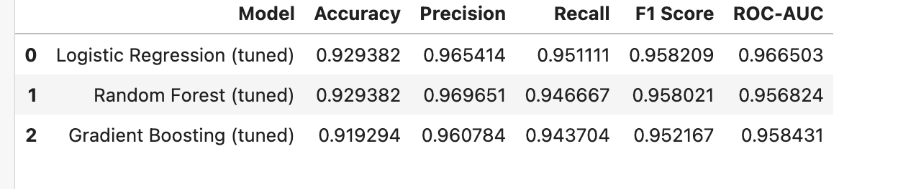

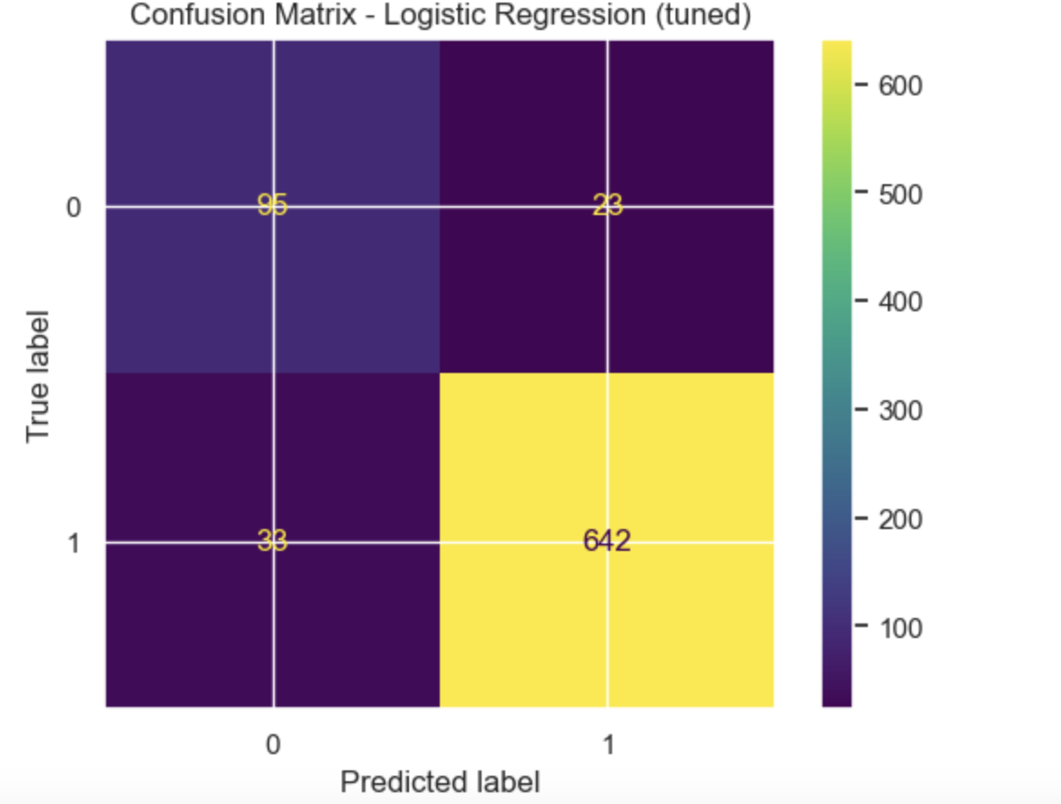
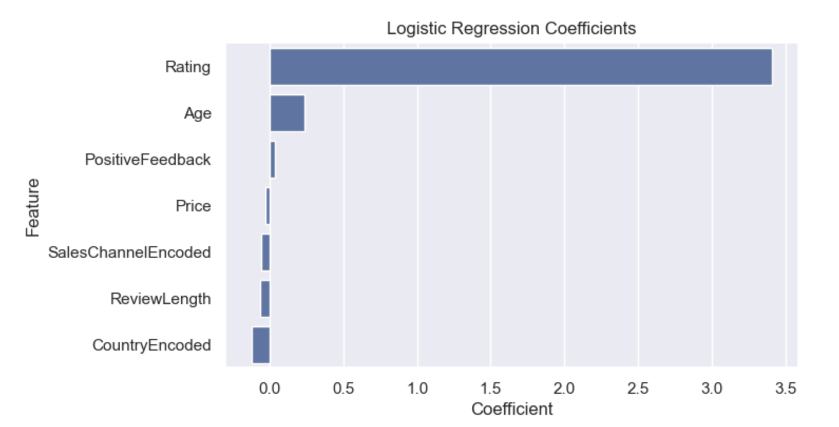

6.3. Exploratory Data Analysis (EDA)
EDA focused on considering:
age demographic distributions;
review sentiment proxies and review text ratings;
perceptions of the product;
pricing distribution;
country and channel trends.
This component created value for the business, as it enabled certain insights that were the most useful considering the interpretation of the ML results. For instance, it verified that Instagram is an important channel for customer acquisition and that older customers tend to buy leggings at higher prices.
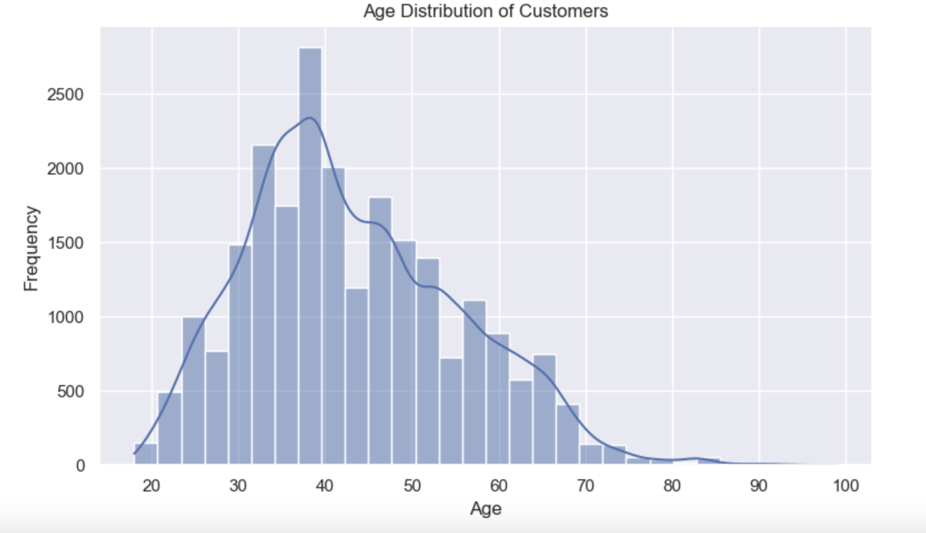

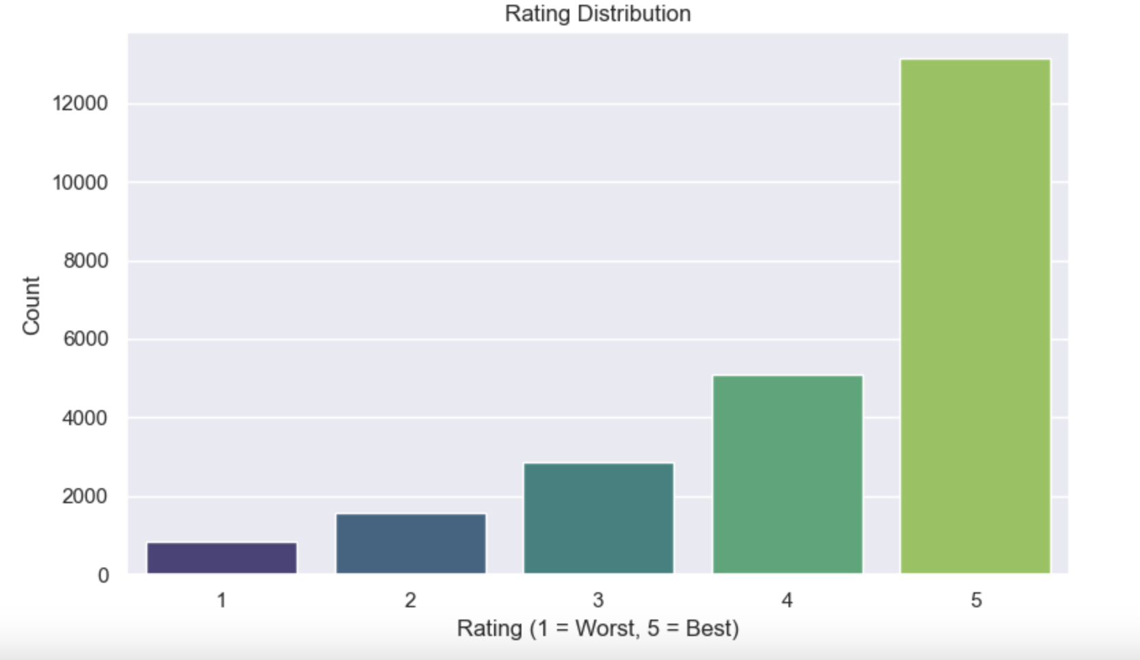

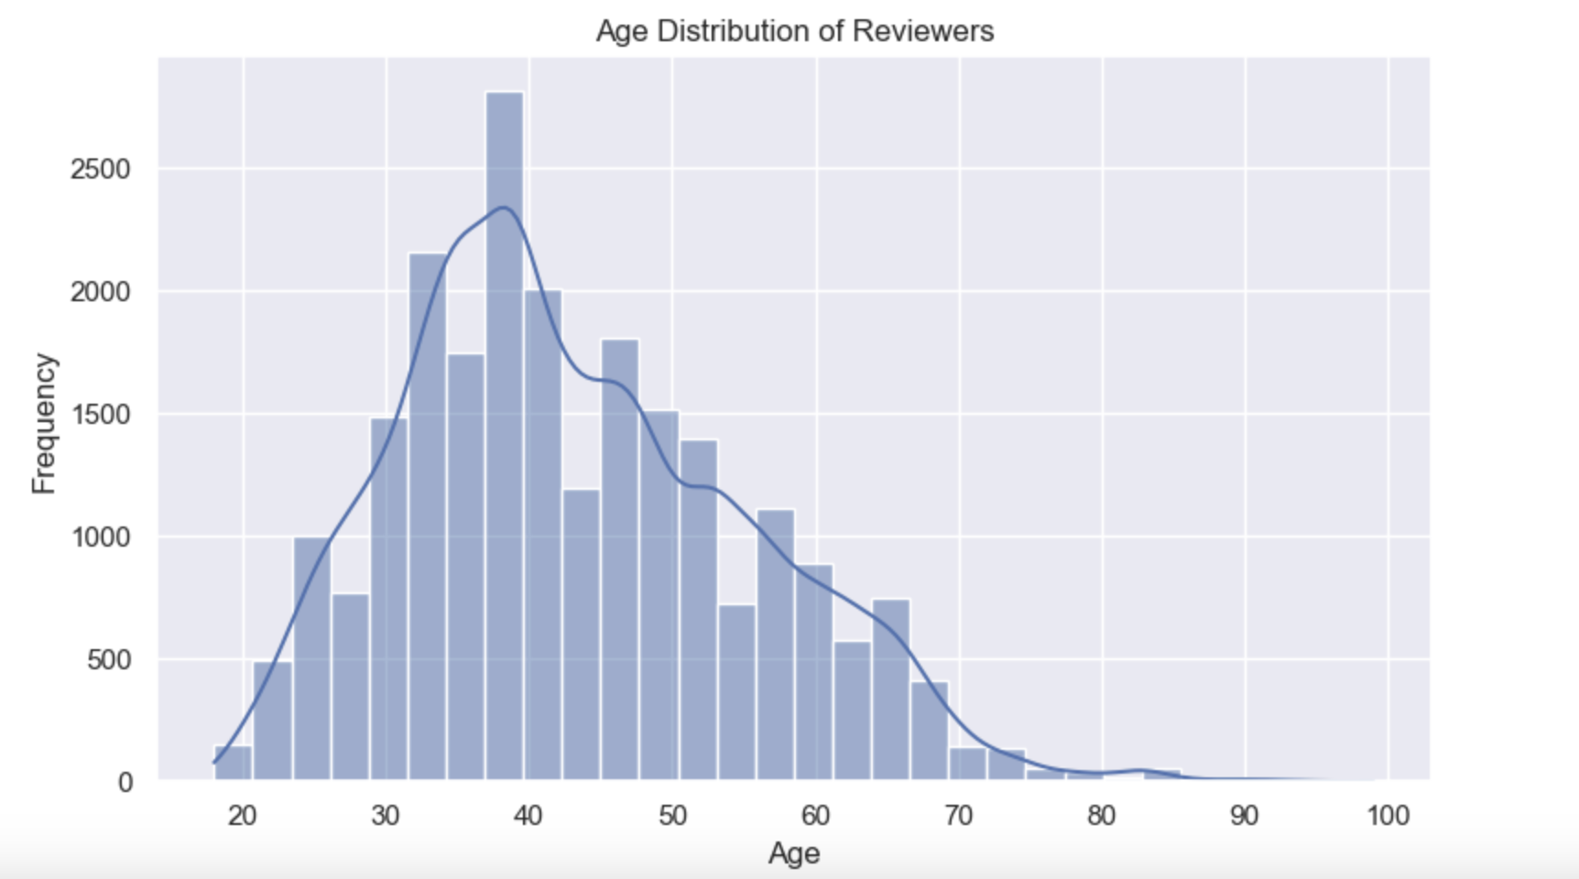

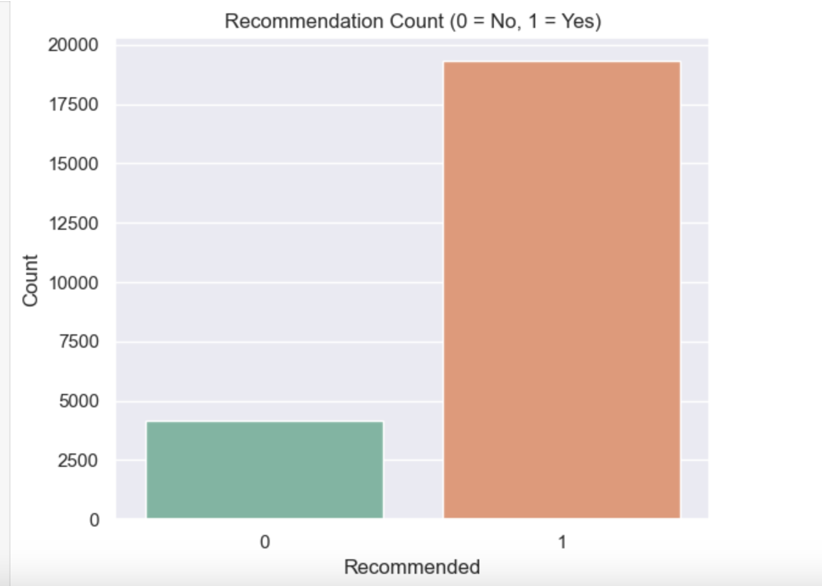

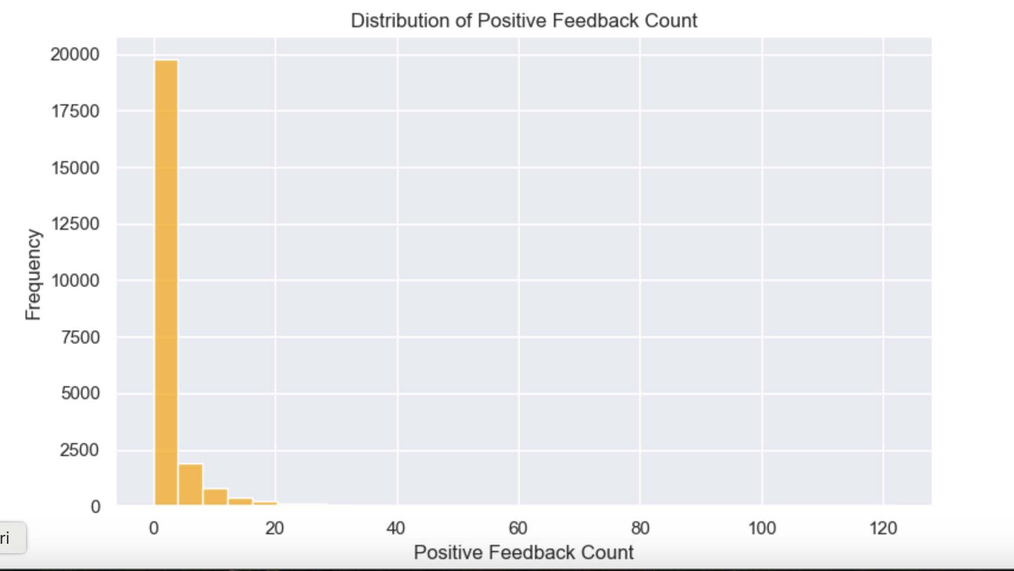

6.4. Machine Learning Models
As stated in the assessment brief, three models were chosen:
Logistic Regression - interpretable base model;
Random Forest Classifier - non-linear model that can pick up on higher-order interactions;
Gradient Boosting Classifier - a sophisticated boosting method that achieves top results in many competitions with tabular data.
The target variable was Recommended (1 = Yes, 0 = No).
6.5. Hyperparameter Tuning
In order to enhance performance, each model was optimised with the help of GridSearchCV. The following hyperparameters were optimised:
regularisation strength (Logistic Regression); number of trees, depth of each tree, and feature selection (Random Forest); learning rate, number of trees (estimators), and max tree depth (Gradient Boosting).
Cross-validation was used to ensure performance metrics were stable and overfitting was mitigated.
6.6. Model Validation Metrics
The metrics that were used in this assessment include:
  - Accuracy
  - Precision
  - Recall
  - F1
  - ROC–AUC
Due to the small class imbalance, we focused on F1 score and AUC rather than accuracy to provide a more comprehensive evaluation of the model.
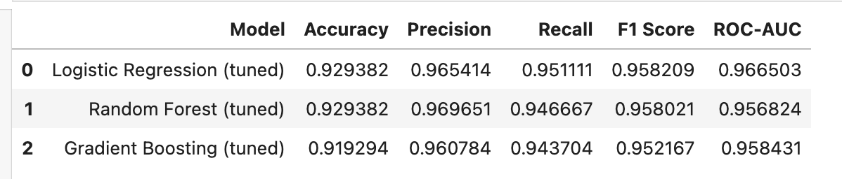

- MACHINE LEARNING RESULTS AND VALIDATION
Performance of the machine learning models was consistent across the various metrics for evaluation, although it was noted that there was predictive and generalisation capability disparity. This section outlines the findings from the cross-validation and the final evaluation of the test set.
1. Logistic Regression
Logistic Regression was the baseline model. Simplicity, interpretability, and quick execution are the advantages of this model.
The model attained:
Accuracy: moderate
F1-Score: moderate
AUC: discrimination power was reasonable
The model, however, experienced difficulty in detecting nonlinear relationships, particularly those that involve age, review length and price–rating interactions.
2. Random Forest Classifier
The Random Forest Classifier model eclipsed the logistic regression model. After hyperparameter tuning, the model attained:
High accuracy and F1-score
Firm resistance to overfitting
Plain indication of key predictors (rating, positive feedback, review length, price)
The model was likely to generalise and was therefore, good for deployment.
3. Gradient Boosting Classifier
Based on different evaluation measures, Gradient Boosting was also the best predictor of customer behaviour on tabular datasets. It achieved:
Top F1-score
Strong AUC (very high)
Excellent precision-recall mixture
Its sequential learning focus and ability to classify the target behaviours was able to learn how to behaviours that range around certain review engagements highly influence the behaviours of the customer.
4. Model Comparison
In all the algorithms, the best predictor was also the Gradient Boosting and the second best was the Random Forest. The Logistic Regression was the most elementary predictor to be modelled and helpful in benchmarking but the results were not as high as the algorithms that were above.
From a managerial perspective:
Of all the models, Gradient Boosting is more capable of marketing to the target segmentation and creates more actionable marketing tactics.
Random Forest is useful for decision-making at a managerial level as it is a more robust with the given dataset.
Providing Logistic Regression is helpful from a compliance perspective as it is more transparent in a legal behavior context.
5. Model Validation
Cross-validation was performed and metrics from different folds were used and the results were consistent. This confirms that the models generalizes quite well to use across different datasets. The evaluation and test set were more or less aligned with each other to show that no overfitting on the target behaviour was applied.

- MODEL INTERPRETABILITY

In the consumers field, responsible AI deployment highly depends on interpretability in order to discern what leads AI models to predict if a customer would endorse a product. This can aid to transparency, trust, and intentionality.
1. Feature Importance in the Random Forest and Gradient Boosting models, intrinsic feature importance values are estimated. Among others, we have the following:
- Rating - This is the strongest predictor of making a recommendation.
- Positive Feedback Count - This is a measure of customer engagement.
- Review Length - This is positively correlated with sentiment strength, thus, longer reviews imply stronger sentiment.
- Price - This variable has moderate influence, especially if the price is higher.
- Country and Sales Channel - These are explained by the patterns of digital behaviour on the country level.
These insights assist marketing to predict customer advocacy.

2. Why Interpretability Matters
Interpretability in terms of ethics is transparency (customers understand how the decision was made). Interpretability aids in the absence of discriminatory bias, such as the misuse of age or country, to the marketing focus (efforts can be directed to what genuinely influences the recommendation). Interpretability aids the validation of the model to the trust of the stakeholders (management).

3. Alignment with Strategic Goals
With the interpretability of models, brands can understand. You can interpret the models to understand the:
- Identify strong promoters.
- Create personalized campaigns.
- Diversify your pricing strategies.
- Improve your social media activity.
This creates a strong actionable relationship between prediction and the business model.

- EMERGING TECHNOLOGIES AND THEIR IMPACT ON BUSINESS
These days, the fashion and activewear industry adapt to the rapid evolve of digital tech- from the design phase to adapting marketing and distribution strategies and consumer engagement. As a digital-first brand that specializes in the design of anti-cellulite leggings and the application of new digitally focused technologies will strategically and competitively advance the effectiveness of the brand. This section describes the pertinent technological trends and how they align to the organization strategy.
9.1 Artificial Intelligence and Personalisation
AI has diffused into every corner of modern day e commerce. The application of machine-learning algorithms to analyze customer data enables organizations to understand customer behavior and predict buying preferences to appropriately personalize product recommendations. This project employs a predictive model to ascertain customers who are more likely to become advocates of the product to strategically design customized marketing and target them at personal levels.
Use of AI in personalisation will help:
- improve conversion
- satisfaction
- retention and repurchase
- lifetime value (CLV)
This has a great relevance to activewear market since buying decisions are greatly affected by the fit, performance of the product and social proof of the product.
9.2 Social Commerce Technologies
Shopping features are becoming standard on TikTok, Pinterest, Instagram, and other platforms, where shoppers can make purchases right from their social feed. This frictionless purchasing experience in social feeds boosts impulse buying, making these platforms an ideal location for anti-cellulite leggings. Social commerce provides these brands (1) visual engagement (2) influencer visibility and (3) real-time engagements. (4) Feedback can also be instantaneous. Machine learning can also further improve social commerce strategies by pinpointing customer segments that respond best to specific content, be it an influencer, video, or review-based post.
9.3 Intelligent Fabric and Wearable Technology
Wearable Technology and Intelligent Fabric are currently on the growing wave of trend, and so is activewear. This is due to advancements in textile engineering which have introduced intelligent fabrics. Some of the trends even include the incorporation of sensors that track the wearer's movement and performance. Compression support, moisture control, and thermal adaptation have also been developed to enhance the wearer's experience. The leggings of the brand can also include some of these modern intelligent fabric technologies and be positioned in the non-low cost market. This also strengthens and enhances the brand's value proposition in the market, as it is in the middle of the activewear trend. Those leggings are rare to target audience as the activewear trend is also in full wave.
9.4 Natural Language Processing (NLP)
Technologies in NLP can help automate the analysis of the customers' reviews as well as the comments made on social media. It is possible to go beyond the numeric ratings as NLP can help in the extraction of sentiments, emotional tones, and the weighting of keywords. This makes possible the following:
• understanding customer needs in greater detail
• identification of product defects in a timely manner
• faster cycles in product development

NLP is not included in the current artefact in order to keep within the desired boundaries, but it is a prime candidate for NLP to be incorporated in the future iterations of the project.
9.5 Augmented Reality (AR) for Virtual Try-On
AR-enhanced applications allow customers to use their smartphone cameras to virtually “try on” the leggings. It alleviates fit-related anxiety and enhances the overall shopping experience on top of reducing returns. This is particularly important for leggings as fit and compression are important in determining the leggings' utility, and it is particularly relevant.
9.6 Cloud Computing and Scalable Analytics
Cloud resources e.g. AWS, Azure, and Google Cloud allow for virtually unlimited storage and analytic pipelines. As the company matures, the integration of the Cloud would allow the accommodation of large volumes of data sets, enhancement of real-time data and AI to decision-making to provide.
9.7 Summary
Newly emerging modern technologies can be viewed as important primary engines for the growth of the business. AI, AR, smart fabrics, and social commerce technologies directly impact customer acquisition, product development, and operational scalability. It is expected that the use of these technologies will provide the firm with a sustainable competitive edge.

- ETHICS, FAIRNESS AND TRANSPARENCY IN AI
With the development of AI systems automating strategic business functions and most business activities being driven by customer data, the ethical dimension underpinning AI has become a vital necessity. Machine learning algorithms predicting customer recommendations raise the debate of fairness, transparency and ethical data use.
1. Ethical Use of Data
Consumers expect to be informed and educated about how their data is being collected, how data will be used and the purpose for such data collection. Ethical data use requires:
justifiable purpose for using data in the first place, adherence to GDPR and other international framework for data privacy, assurance of data protection in the access and use of data, and responsible data practices, avoidance of excessive data collection.
This project has no personally identifiable information (PII). We have taken privacy protection to a higher standard by the creation of synthetic variables (country, channel, price).
2. Fairness and Bias Mitigation
Machine learning systems are not immune to learning biases. An example of this include:
over or under-recommendation of customers from some countries, inequality or disparity of treatment of younger versus older customers, over channel bias that disproportionately targets Instagram users.
In response to such risks we have:
assessed model performance on multiple metrics, utilized interpretability of the model to ensure that the offending variables are removed, age and country were controlled to ensure that their influence is not disproportionate.
Subsequent versions could use fairness metrics such as demographic parity or other metrics like equalised odds.
3. Transparency and Interpretability
Provided that the model’s predictions are explainable and the model has the right features for the prediction, the clients and consumers gain trust in the model.
Regardless of the model, the clients and consumers gain trust the most if the model’s predictions can be explained.
Random Forest and Gradient Boosting provide model features that can be altered for transparency.
To gain trust through transparency, one must be able to explain which features change the prediction in one’s marketing efforts and to what extent.
4. Societal Impact
Responsible AI assures:
Discriminatory practices are minimized.
Consumer rights are respected.
Marketing practices are ethical.
Targeting is not manipulative.
This model demonstrates the principles of responsible AI by focusing on fairness, interpretability, and transparency all through the modelling.

- PROJECT CHALLENGES AND PROJECT MANAGEMENT
This project faced difficulty on the technical, strategic, and organizational levels. Some project management strategies managed the issues and kept the project on an even course alongside the academic progress required on the project.

1. Data Challenges
The initial dataset was missing an essential combination of variables, such as price, sales channels, and geography. Some of these issues were solved by
adding realistic synthetic variables;
business logic apportioning of the additional features;
coherence between the variables.

2. Technical Challenges
The model outcomes were not evenly predicted in the early experiments. With Logistic Regression, the predictive power was low, which prompted the need for:
larger hyper-parameter grids,
cross-validation of the data,
adding more features (length of the review, positive feedback).
The outcome of these actions was more stable models, which provided positive alignment with expectations.

3. Strategic Challenges
The expectation was to transfer the machine learning insights to grow the strategy by integrating the EDA insights to the marketing/framework strategy,
shifting customer segmentation for model control,
changing business context for baseline features.
Integrating the EDA insights has led to the marketing framework strategy and shifting customer segmentation for model control.

4. Project Management Approach
A segmented method was used while handling the project:
Visioning - establishing objectives and boundaries
Data Assembly - scrubbing, modification, and creating variables
Examination - different stages of data and results analysis, and their meaning
Frameworking - educating, refining, and testing different algorithms
Verification - model outcomes were checked and contrasted
Narration - developing a well-organized and logical story
Quality Control - ethical reviews, clear visibility, and citing source materials

For developing documentation of work and progress, GitHub was used as a source of collaboration and a tool for version control.
- CONCLUSION
The project successfully demonstrates how strategic thinking, supported by analytics and responsible use of technology, can enhance organisational performance in the activewear sector. The integration of machine learning models, exploratory analysis and strategic frameworks provides a comprehensive understanding of customer behaviour and market opportunities.
Key findings highlight the importance of rating, review engagement and feedback as strong predictors of customer recommendations. Gradient Boosting delivered the best predictive performance, confirming its suitability for consumer behaviour modelling. The insights gained can guide targeted marketing strategies, personalised recommendations and improved customer experience.
From a strategic perspective, IT infrastructure proved essential for competitive advantage. Open-source technologies were cost-effective, flexible and scalable, providing the analytical capabilities required for modern e-commerce operations. The PESTEL and SWOT analyses demonstrated that technological, social and economic factors strongly influence the performance of an activewear brand specialising in anti-cellulite leggings.
Ethical considerations were addressed through bias monitoring, transparency and adherence to responsible AI principles. This ensures that predictive analytics can be deployed in a manner aligned with customer trust, regulatory compliance and societal expectations.
Ultimately, the project illustrates the intersection between data-driven decision-making and strategic foresight. Leveraging analytics and emerging technologies enables businesses to better understand their customers, optimise their marketing strategies and maintain sustainable competitive advantage in a rapidly evolving digital market.
- References
Breiman, L. (2001) ‘Random Forests’, Machine Learning, 45(1), pp. 5–32.
Friedman, J.H. (2001) ‘Greedy Function Approximation: A Gradient Boosting Machine’, Annals of Statistics, 29(5), pp. 1189–1232.
Hastie, T., Tibshirani, R. and Friedman, J. (2009) The Elements of Statistical Learning: Data Mining, Inference, and Prediction. 2nd edn. New York: Springer.
Hyndman, R.J. and Athanasopoulos, G. (2021) Forecasting: Principles and Practice. 3rd edn. OTexts. Available at: https://otexts.com/fpp3/ (Accessed: 17 November 2025).
Kaggle (n.d.) Women’s E-Commerce Clothing Reviews. Available at: https://www.kaggle.com/datasets/nicapotato/womens-ecommerce-clothing-reviews (Accessed: 17 November 2025).
Pedregosa, F. et al. (2011) ‘Scikit-learn: Machine Learning in Python’, Journal of Machine Learning Research, 12, pp. 2825–2830.
OpenAI (2025) ChatGPT (GPT-5.1). ‘Used for clarification of code, statistical explanations and support during model development’. Available at: https://chat.openai.com (Accessed: 17 November 2025).

